

**Voice Controlled car using Bluetooth Module.**

**ECB4243 DESIGNPROJECT-II**

* **Submitted by:**

|  |  |  |
| --- | --- | --- |
| **S.NO** | **TEAM MEMBER** | **REGISTER NUMBER** |
| **1.** | Praveen kumar.T | 19121084 |
| **2.** | Revanth.P | 19121081 |
| **3.** | Siva reddy | 19121061 |

***As a part of the second year***

***curriculum of***

**#ECE-DEPARTMENT HINDUSTAN UNIVERSITY**

**School of Electrical Sciences**

**April 2021**

**Padur, Kancheepuram,**

**Tamil nadu.**

* TABLE OF CONTENTS

|  |  |  |
| --- | --- | --- |
| S.NO | TITTLE | page NO |
| 1. | **ACKNOWLEDGEMENT** | i |
| 2. | **ABSTRACT** | **ii-iii** |
| 3. | **TABLE OF CONTENTS** | iv |
| 4. | **LIST OF FIGURES** | v |
| 5. | **1.INTRODUCTION** | 1-2 |
| 6. | **2.LITERATURE SURVEY** | 3-6 |
| 7. | **3.SYSTEM ANALYSIS**  **3.1 Components description**  **3.2 Project description**  **3.3 Applications and advantages** | 7-23 |
| 8. | **4.RESULT ANALYSIS** | 24- |
| 9. | **5.CONCLUSION &FUTURE WORK**  **5.1 Conclusion**  **5.2 Future work** |  |
| 10. | **REFERENCES** |  |
| 11. | **APPENDIX** |  |
|  |  |  |

**ACKNOWLEDGEMENT :**

**ABSTRACT:**

This Work is based on Arduino, motor driver and Bluetooth module. Arduino is an opensource prototyping platform Based on easy-to-use hardware and software. Arduino uses an ATmega328 microcontroller. Since robotics has become a major part in our daily life and also in the engineering field and it plays a vital role in the development of new technology. This is a very simple and easy type form of remote control car, where the ordinary micro-controller has been replaced by Arduino and IR sensors has been replaced by a Bluetooth module. The remote can be any android or IOS cell phones. This project can be made in a bigger scale for real time vehicles.

In this project, I will show you how to design and develop a Bluetooth Controlled Robot using Arduino, HC-05 Bluetooth Module and L298N Motor Driver Module. On the other end of the Bluetooth Communication, I will be using a Smart Phone and a simple Android App to control the Robotic Car

**CHAPTER 1**

**INTRODUCTION**

Robots are always a fancy topic for students, hobbyists and DIYers. If you are beginner, then building a robot (like a car or an arm) is probably one of the important projects to do after learning about the basics.

If you remember the earlier tutorial, I have discussed about HC-05 Bluetooth Module and how to interface one with Arduino. Also, I have provided a simple Bluetooth Controller App, which can be installed on your Android Phone and start transmitting the data.

As a continuation to that project, I will be implementing Bluetooth Controlled Robot using Arduino and a few other components and build a simple robotic car that can be controlled using an Android Phone (through an App) over Bluetooth Communication.

## Voice and Speech Voice is a sound which is produced by living beings. Voice uses airflow that comes from lungs. Air makes pressure over vocal folds which vibrate. Normally speech produces a whisper in our throat by using neck, chest, and abdomen this whisper becomes our speech. Our speech is unique for every person and also it helps other people to understand each other’s personality, mood and most importantly it helps . people to communicate. Sounds propagate using mechanical waves for traveling around gases, liquids and solids. Mechanical waves transfer their energy from one medium to another medium while using vibration. Microphone is a hardware device which can convert analog input to a digital output. Digital data can be understood, modify and store by computers. Computers can recognize speech by using some complex algorithms and good dictionaries for these algorithms. Some systems use the Hidden Markov Model (HMM) and the Mel frequency cepstral coefficients (MFCC) techniques as well as the techniques of frequency spectral decomposition to use these two algorithms.

## Arduino Communication To communicate with Arduino we first need to install its free software from the internet and install. The software is very easy to use and installing it creates just one .uno files on the microprocessors these files confuse the user because there are many different files generating. After installing Arduino it is ready to usage including dictionaries using dictionaries is very easy on the Arduino and Arduino does not requires any configuration setting when programming. User can use USB cable to connect Arduino and after that user can dump his code to Arduino far more easily and quickly than micro-controller. C. Bluetooth Communication Bluetooth is one of the popular devices to communicate in short range it is used on computers, cell phones, head phones and many other devices. Bluetooth devices use 2.4 to 2.5 GHz frequency to communicate with each other. Bluetooth standardized as IEEE 802.15.1 but then it changed that 802.15.1 Bluetooth’s range is 2400–2483.5 MHz approximately. Bluetooth devices generally use frequency-hopping spread spectrum communication technique to communicate with each other.

**CHAPTER 2**

**LITERATURE SURVEY**

# 1. The voice control robot we develop uses arduino UNO which facilitates multi tasking.

# 2. Our work differs from other previous works in selecting the components and mapping of algorithms and coding.

# 3.Many projects are build using GPS, infrared sensor and others for obstacle avoiding and voice control but we made it simple using a DC motor.

Conventional Wireless Robotics: A robot is a mechanical or virtual artificial agent, usually an electro-mechanical machine that is guided by a computer program or electronic circuitry in conventional robotics, the controlling and operation of robots is usually done by using RF [Radio Frequency] circuits Bluetooth: Bluetooth is a wireless technology standard for exchanging data over short distances from fixed and mobile devices, and building personal area networks. Bluetooth technology was created by Ericsson in 1994 and is used to replace the cables in the office, in laboratories or at home as in. Bluetooth device operated in the range of 10 meters

### Prerequisites for Bluetooth Controller Robot

Apart from Arduino, which is the main controlling module of the project, there are two other important modules that you have to be familiar with in order to implement the Bluetooth Controlled Robot project.

They are the HC-05 Bluetooth Module and the L298N Motor Driver Module.

#### HC-05 Bluetooth Module

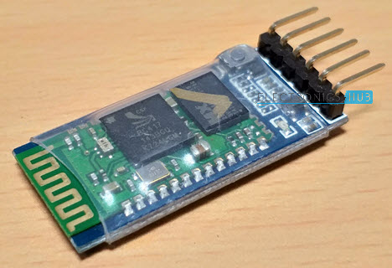

The HC-05 Bluetooth Module is responsible for enabling Bluetooth Communication between Arduino and Android Phone.

For more information on HC-05 Bluetooth Module, refer to [**HC-05 BLUETOOTH MODULE**](https://www.electronicshub.org/hc-05-bluetooth-module/).

#### L298N Motor Driver Module

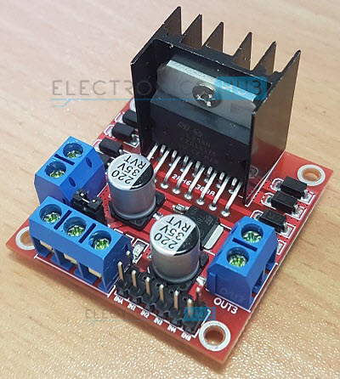

The L298N Motor Driver Module is responsible for providing the necessary drive current to the motors of the robotic car. I have provided information about L298N Module in an earlier project called Arduino DC Motor Control using L298N.

So, refer to [**ARDUINO DC MOTOR CONTROL USING L298N**](https://www.electronicshub.org/arduino-dc-motor-control-using-l298n/) for more information on interfacing L298N with Arduino.

**CHAPTER 3**

**SYSTEM ANALYSIS**

**3.1-COMPONENTS DESCRIPTION:**

The components which we had used in this project are:

|  |  |  |
| --- | --- | --- |
| S.NO | COMPONENTS | QUANTITY |
| 1. | **ARDUINO UNO** | **1** |
| 2. | **Jumper wires (male to male) (female to male)** | **1 set.** |
| 3. | **MOTOR DRIVER MODULE (L)** | **1** |
| 4. | **MOTORS** | **2** |
| 5. | **WHEELS** | **2** |
| 6. | **BLUETOOTH MODULE(HC-05)** | **1** |
| 7. | **ARDUINO CABLE** | **1** |
| 8. | **9V BATTERY AND CONNECTOR** | 1 |

**1.ARDUINO UNO:**  The Arduino Uno is an [open-source](https://en.wikipedia.org/wiki/Open-source) [microcontroller board](https://en.wikipedia.org/wiki/Microcontroller_board) based on the [Microchip](https://en.wikipedia.org/wiki/Microchip_Technology) [ATmega328P](https://en.wikipedia.org/wiki/ATmega328P) microcontroller and developed by [Arduino.cc](https://en.wikipedia.org/wiki/Arduino). The board is equipped with sets of digital and analog [input/output](https://en.wikipedia.org/wiki/Input/output) (I/O) pins that may be interfaced to various [expansion boards](https://en.wikipedia.org/wiki/Expansion_board) (shields) and other circuits. The board has 14 digital I/O pins (six capable of [PWM](https://en.wikipedia.org/wiki/Pulse-width_modulation) output), 6 analog I/O pins, and is programmable with the [Arduino IDE](https://en.wikipedia.org/wiki/Arduino#Software) (Integrated Development Environment), via a type B [USB cable](https://en.wikipedia.org/wiki/USB_cable).

The 14 digital input/output pins can be used as input or output pins by using pinMode(), digitalRead() and digitalWrite() functions in arduino programming. Each pin operate at 5V and can provide or receive a maximum of 40mA current, and has an internal pull-up resistor of 20-50 KOhms which are disconnected by default.  Out of these 14 pins, some pins have specific functions as listed below:

* **Serial Pins 0 (Rx) and 1 (Tx):** Rx and Tx pins are used to receive and transmit TTL serial data. They are connected with the corresponding ATmega328P USB to TTL serial chip.
* **External Interrupt Pins 2 and 3:** These pins can be configured to trigger an interrupt on a low value, a rising or falling edge, or a change in value.
* **PWM Pins 3, 5, 6, 9 and 11:** These pins provide an 8-bit PWM output by using analogWrite() function.
* **SPI Pins 10 (SS), 11 (MOSI), 12 (MISO) and 13 (SCK):** These pins are used for SPI communication.
* **In-built LED Pin 13:** This pin is connected with an built-in LED, when pin 13 is HIGH – LED is on and when pin 13 is LOW, its off.

Along with 14 Digital pins, there are 6 analog input pins, each of which provide 10 bits of resolution, i.e. 1024 different values. They measure from 0 to 5 volts but this limit can be increased by using AREF pin with analog Reference() function.

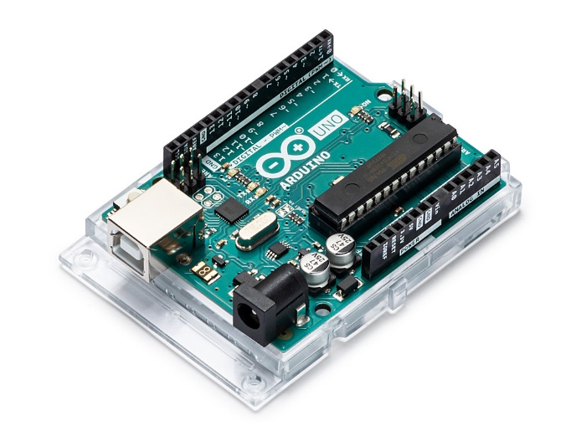

Fig-1

* Analog pin 4 (SDA) and pin 5 (SCA) also used for TWI communication using Wire library.

Arduino Uno has a couple of other pins as explained below:

* **AREF:** Used to provide reference voltage for analog inputs with analog Reference () function.
* **Reset Pin:**Making this pin LOW, resets the microcontroller.

### **Applications**

* Prototyping of Electronics Products and Systems
* Multiple DIY Projects.
* Easy to use for beginner level DIYers and makers.
* Projects requiring Multiple I/O interfaces and communications.

**2.JUMPER WIRES:**

A jump wire (also known as jumper wire, or jumper) is an [electrical wire](https://en.wikipedia.org/wiki/Electrical_wire), or group of them in a cable, with a connector or pin at each end, which is normally used to interconnect the components of a [breadboard](https://en.wikipedia.org/wiki/Breadboard) or other prototype or test circuit, internally or with other equipment or components, without soldering.

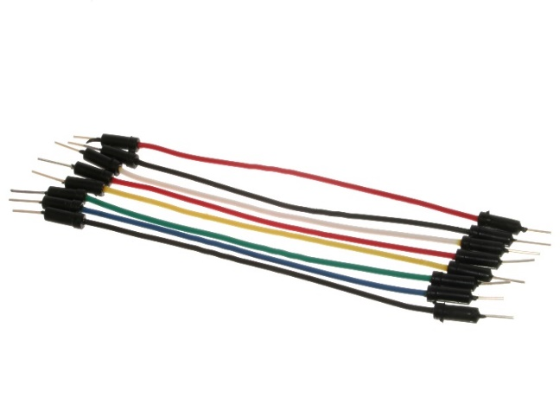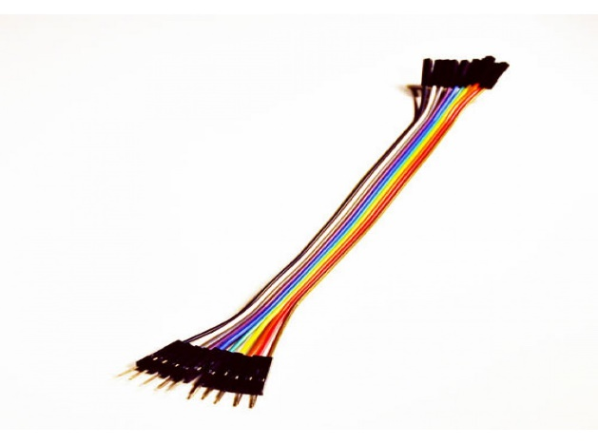

3) Motor driver module

The L298N is an integrated monolithic circuit in a 15- lead Multiwatt and PowerSO20 packages. It is a high voltage , high current dual full-bridge driver de-signed to accept standard TTL logic level sand drive inductive loads such as relays, solenoids, DC and stepping motors. Two enable inputs are provided to enable or disable the device independently of the in-put signals .The emitters of the lower transistors of each bridge are connected together rand the corresponding external terminal can be used for the connection of an external sensing resistor. An additional Supply input is provided so that the logic works at a lower voltage.  
Its schematic diagram is as shown in figure (a):  
[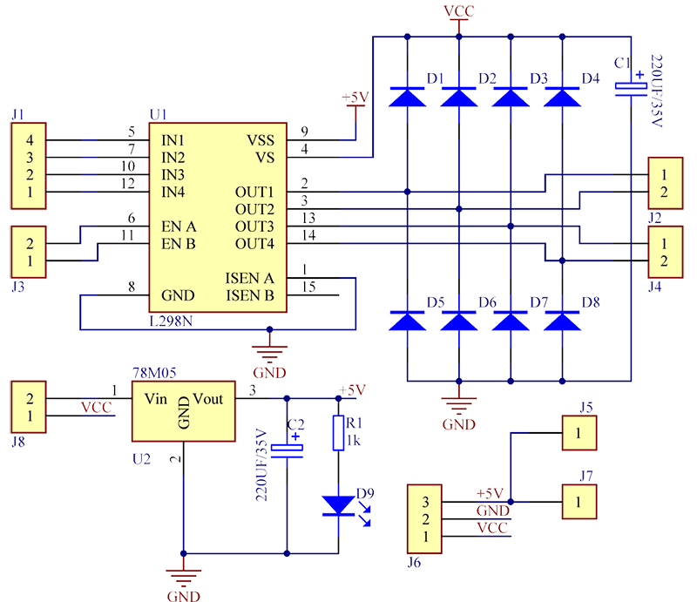](http://wiki.sunfounder.cc/index.php?title=File:Motor2.png)  
(a)Schematic diagram for motor drive module

## Features

1) High operating voltage, which can be up to 40 volts;  
2) Large output current, the instantaneous peak current can be up to 3A;  
3) With 25W rated power;  
4) Two built in H-bridge, high voltage, large current, full bridge driver, which can be used to drive DC motors, stepper motors, relay coils and other inductive loads.  
5) Using standard logic level signal to control.  
6) Able to drive a two-phase stepper motor or four-phase stepper motor, and two-phase DC motors.  
7) Adopt a high-capacity filter capacitor and a freewheeling diode that protects devices in the circuit from being damaged by the reverse current of an inductive load, enhancing reliability  
8) The module can utilize the built-in stabilivolt tube 78M05 to obtain 5v from the power supply. But to protect the chip of the 78M05 from damage, when the drive voltage is greater than 12v, an external 5v logic supply should be used.  
9) Drive voltage: 5-35V; logic voltage: 5V  
10) PCB size: 4.2 x 4.2 cm

## Pin Function

[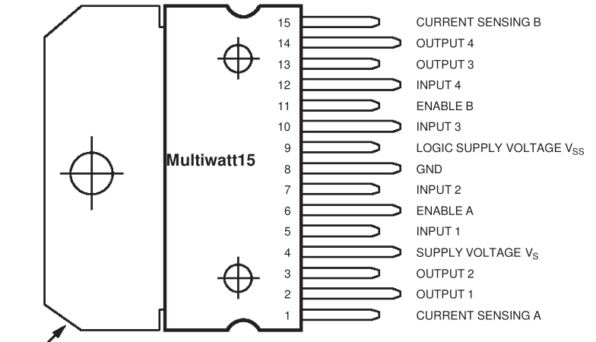](http://wiki.sunfounder.cc/index.php?title=File:Motor3.png)  
Its pin functions are as shown in table (1):  
[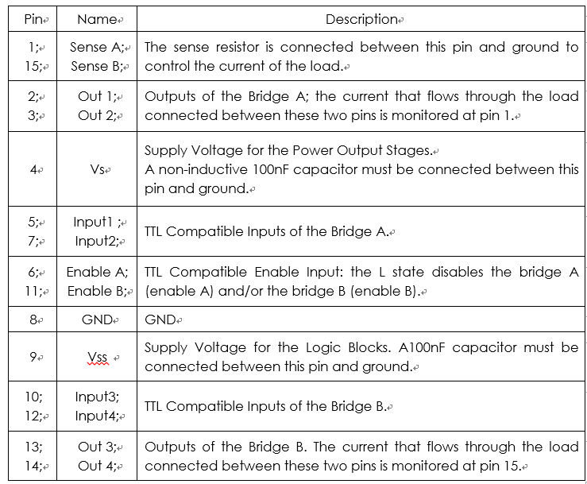](http://wiki.sunfounder.cc/index.php?title=File:Motor4.png)  
(1) Table for L298N pin functions

## Principle

The driver module can drive two motors. The enabled terminals ENA and ENB are effective at high level. The control mode and state of motor A are as shown in table (2):  
[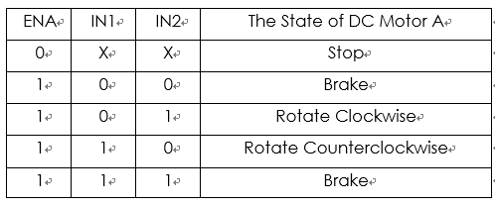](http://wiki.sunfounder.cc/index.php?title=File:Motor5.png)  
(2) Table for control mode and state of motor A  
If you want to regulate the speed of motor A by PWM, you need to set IN1 and IN2, confirm the rotational direction of the motor, and then output PWM pulses for enabled terminals. Please note the motor is in the free stop state when the signal of enabled terminal is 0. When the enabled signal is 1, if IN1 and IN2 are 00 or 11, the motor is in brake state, and the motor stops rotating. If IN1 is 0 and IN2 is 1, the motor A rotates clockwise; if IN1 is 1 and IN2 is 0, the motor A rotates counterclockwise. This is the control method for motor A. The control method for motor B is the same as that for motor A.

## Block Diagram

[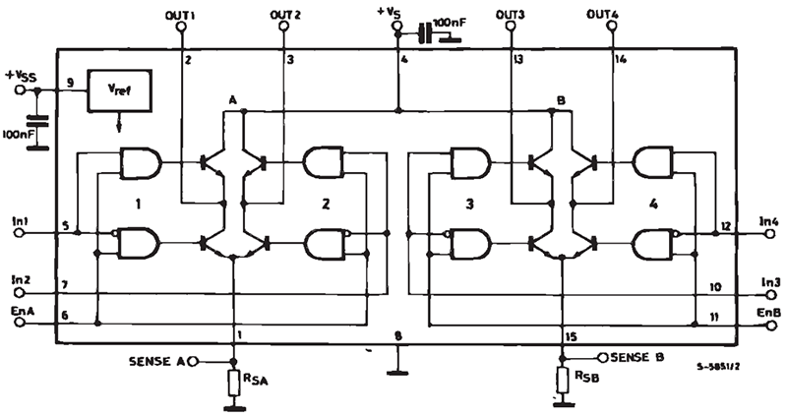](http://wiki.sunfounder.cc/index.php?title=File:Motor6.png)

## Application

The module can be applied to: - Drive DC motors. Since the module uses a dual H-bridge drive, it can drive two motors at the same time.  
- Drive stepping motors. It can also drive two stepping motors synchronously.

3)MOTOR DRIVER MODULE (L):

#### **L298N Motor Driver Module**

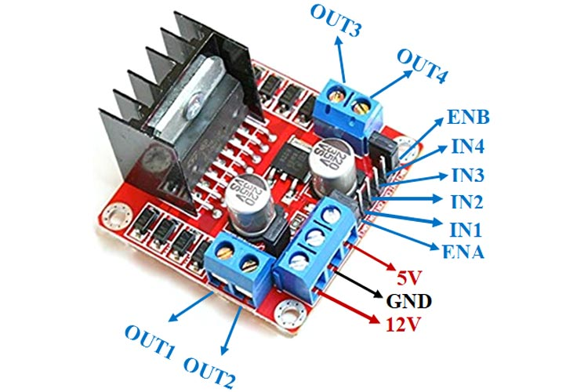

This **L298N Motor Driver Module** is a high power motor driver module for driving DC and Stepper Motors. This module consists of an L298 motor driver IC and a 78M05 5V regulator. **L298N Module** can control up to 4 DC motors, or 2 DC motors with directional and speed control.

### **L298 Module Features & Specifications:**

* Driver Model: L298N 2A
* Driver Chip: Double H Bridge L298N
* Motor Supply Voltage (Maximum): 46V
* Motor Supply Current (Maximum): 2A
* Logic Voltage: 5V
* Driver Voltage: 5-35V
* Driver Current:2A
* Logical Current:0-36mA
* Maximum Power (W): 25W
* Current Sense for each motor
* Heatsink for better performance
* Power-On LED indicator

### **Brief about L298N Module:**

The L298N Motor Driver module consists of an L298 Motor Driver IC, 78M05 Voltage Regulator, resistors, capacitor, Power LED, 5V jumper in an integrated circuit.

78M05 Voltage regulator will be enabled only when the jumper is placed. When the power supply is less than or equal to 12V, then the internal circuitry will be powered by the voltage regulator and the 5V pin can be used as an output pin to power the microcontroller. The jumper should not be placed when the power supply is greater than 12V and separate 5V should be given through 5V terminal to power the internal circuitry.

ENA & ENB pins are speed control pins for Motor A and Motor B while IN1& IN2 and IN3 & IN4 are direction control pins for Motor A and Motor B.

Internal circuit diagram of L298N Motor Driver module is given below:

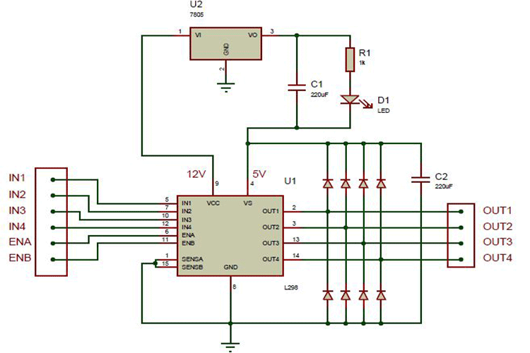

### **Applications of L298N Module :**

* Drive DC motors.
* Drive stepping motors
* In Robotics

**4) MOTORS :**

The circuit comprises of Arduino UNO Board, HC-05/HC-06 **Bluetooth Module**, L293D **Motor** Driver IC, a couple of DC Geared **Motors** of 200 RPM and a 9V Battery. The TX, RX pins of Arduino is associated with Rx, Tx pins of **Bluetooth Module**. The **Bluetooth Module** is provided with 5V.

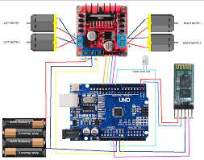

**BLUETOOTH MODULE(HC-05)**

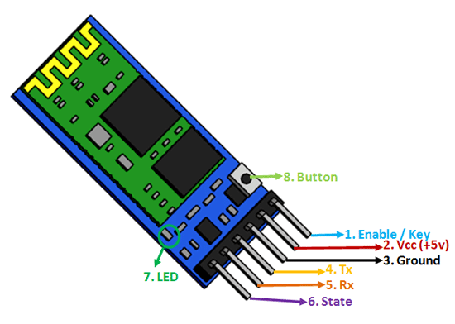

### **Pin Configuration :**

|  |  |  |
| --- | --- | --- |
| **Pin Number** | **Pin Name** | **Description** |
| 1 | Enable / Key | This pin is used to toggle between Data Mode (set low) and AT command mode (set high). By default it is in Data mode |
| 2 | Vcc | Powers the module. Connect to +5V Supply voltage |
| 3 | Ground | Ground pin of module, connect to system ground. |
| 4 | TX – Transmitter | Transmits Serial Data. Everything received via Bluetooth will be given out by this pin as serial data. |
| 5 | RX – Receiver | Receive Serial Data. Every serial data given to this pin will be broadcasted via Bluetooth |
| 6 | State | The state pin is connected to on board LED, it can be used as a feedback to check if Bluetooth is working properly. |
| 7 | LED | Indicates the status of Module   * Blink once in 2 sec: Module has entered Command Mode * Repeated Blinking: Waiting for connection in Data Mode |

### **HC-05 Technical Specifications**

* Serial Bluetooth module for [Arduino](https://components101.com/microcontrollers/arduino-uno) and other microcontrollers
* Operating Voltage: 4V to 6V (Typically +5V)
* Operating Current: 30mA
* Range: <100m
* Works with Serial communication (USART) and TTL compatible
* Follows IEEE 802.15.1 standardized protocol
* Uses Frequency-Hopping Spread spectrum (FHSS)
* Can operate in Master, Slave or Master/Slave mode
* Can be easily interfaced with Laptop or Mobile phones with Bluetooth
* Supported baud rate: 9600,19200,38400,57600,115200,230400,460800.

### **Where to use HC-05 Bluetooth module**

The **HC-05** is a very cool module which can add two-way (full-duplex) wireless functionality to your projects. You can use this module to communicate between two microcontrollers like Arduino or communicate with any device with Bluetooth functionality like a Phone or Laptop. There are many android applications that are already available which makes this process a lot easier. The module communicates with the help of USART at 9600 baud rate hence it is easy to interface with any microcontroller that supports USART. We can also configure the default values of the module by using the command mode. So if you looking for a Wireless module that could transfer data from your computer or mobile phone to microcontroller or vice versa then this module might be the right choice for you. However do not expect this module to transfer multimedia like photos or songs; you might have to look into the CSR8645 module for that.

### **How to Use the HC-05 Bluetooth module**

The **HC-05** has two operating modes, one is the Data mode in which it can send and receive data from other Bluetooth devices and the other is the AT Command mode where the default device settings can be changed. We can operate the device in either of these two modes by using the key pin as explained in the pin description.

It is very easy to pair the HC-05 module with microcontrollers because it operates using the Serial Port Protocol (SPP). Simply power the module with +5V and connect the Rx pin of the module to the Tx of MCU and Tx pin of module to Rx of MCU as shown in the figure below

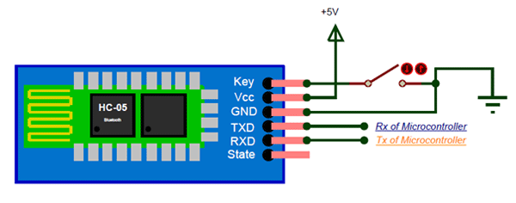

During power up the key pin can be grounded to enter into Command mode, if left free it will by default enter into the data mode. As soon as the module is powered you should be able to discover the Bluetooth device as “HC-05” then connect with it using the default password 1234 and start communicating with it. The name password and other default parameters can be changed by entering into the

### **Applications :**

1. Wireless communication between two microcontrollers

2. Communicate with Laptop, Desktops and mobile phones

3. Data Logging application

4. Consumer applications

5. Wireless Robots

6. Home Automation

**9V BATTERY AND CONNECTOR :**

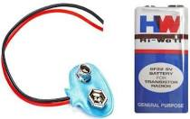

**3.2-PROJECT DESCRIPTION:**

### Circuit Diagram of Bluetooth Controlled Robot

The following is the circuit diagram of Bluetooth Controlled Robot using Arduino, L298N and HC-05.

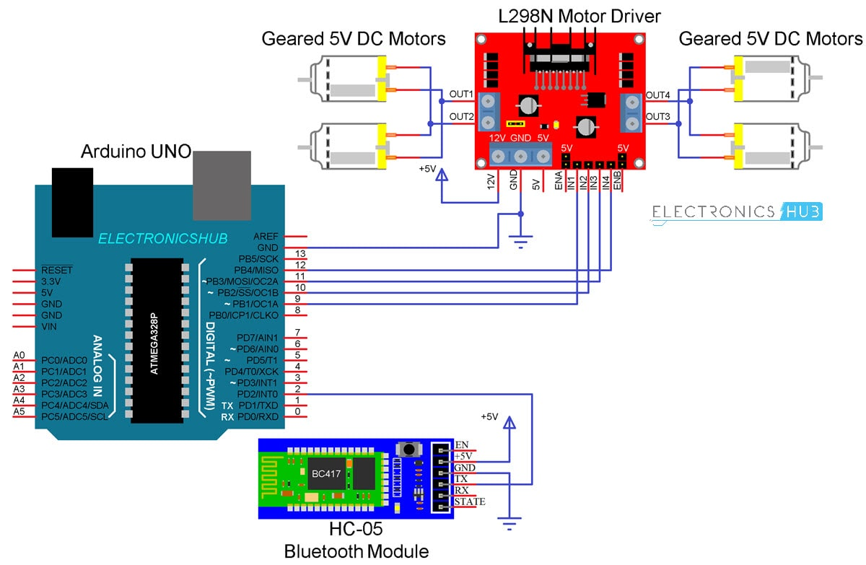

#### Circuit Design

I wouldn’t go into the details of the construction of the robot as your robot chassis might be different from mine and you can easily figure it out how to build the robot from the available parts and possible cable management for making the robot more appealing.

Coming to the design of the circuit, first is the HC-05 Bluetooth Module. The +5V and GND pins of the Bluetooth Module are connected to +5V and GND of Arduino.

Since I will be only transmitting data related to the Robot’s movement from Android Phone to Bluetooth Module and do not intend to receive any data from Arduino, I will connect only the TX pin of the Bluetooth Module to RX Pin of Arduino.

This RX pin of Arduino is based on SoftwareSerial library (Pin 2 and Pin 3 are configured as RX and TX on Arduino). The RX pin of the Bluetooth is left open.

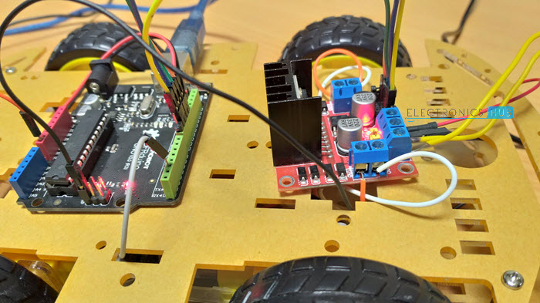 Now, the L298N Motor Driver Module. Digital I/O Pins 9 through 12 of Arduino are configured as Input pins of the Motor Driver and are connected to IN1 through IN4 of the L298N Motor Driver Module. Both the Enable Pins are connected to 5V through provided jumper.

The robot chassis which I am using in this Bluetooth Controlled Robot Car project is supplied with 4 geared motors. Since L298N has slots for only two motors, I have joined the left side motors as one set and the right side motors as other set and connected both these sets to the output of L298N Module.

### Code

#include <SoftwareSerial.h>

SoftwareSerial BT(10, 11); //TX, RX respetively String readvoice;

#define in1 3

#define in2 4

#define in3 5

#define in4 6

void setup() { BT.begin(9600); Serial.begin(9600); pinMode(in1, OUTPUT); pinMode(in2, OUTPUT); pinMode(in3, OUTPUT); pinMode(in4, OUTPUT);

}

void loop()

{

while (BT.available()){ //Check if there is an available byte to read delay(10); //Delay added to make thing stable

char c = BT.read(); //Conduct a serial read

readvoice += c; //build the string- "forward", "reverse", "left" and "right"

if (readvoice.length() > 0) { Serial.println(readvoice);

if(readvoice == "forward")

{

digitalWrite(in1, HIGH);

digitalWrite(in2, HIGH);

digitalWrite(in3,LOW);

digitalWrite(in4,LOW);

delay(100);

}

else if(readvoice == "reverse")

{

digitalWrite(in1, LOW);

digitalWrite(in2, LOW);

digitalWrite(in3, HIGH);

digitalWrite(in4,HIGH);

delay(100);

}

}

else if (readvoice == "stop")

{

digitalWrite (in1, LOW);

digitalWrite (in2, LOW);

digitalWrite (in3, LOW);

digitalWrite (in4, LOW);

delay (100);

}

readvoice=""; //Reset the variable

}

}

### Android App

If you remember the HC-05 Bluetooth Module tutorial, I have used a simple app called Bluetooth Controller, which is installed on an Android Phone to communicate with the Bluetooth Module.

### Working

Assemble the robot, make the necessary connections and upload the code to Arduino. If you understood the HC-05 Bluetooth Module tutorial, then understanding the Bluetooth Controlled Robot project is very easy.

First, in the Android App, I have used 5 keys as Forward, Reverse, Left, Right and Stop. The corresponding data associated with each key is as follows:

* Forward – 1
* Reverse – 2
* Left – 3
* Right – 4
* Stop – 5

When a key is pressed, the corresponding data is transmitted to the Bluetooth Module from the Phone over Bluetooth Communication.

### Bluetooth-Controlled-Robot-using-Arduino-Working.jpg

**CONNECTION DIAGRAM**

### diy-android-controlled-robot-car-gadgetronicx.jpg

### Limitations

* As the range of the Bluetooth Communication is limited (a maximum of 10 meters for class 2 devices for example) the control range of Bluetooth Controlled Robot is also limited.
* Make sure that sufficient power is provided to all the modules especially the Bluetooth Module. If the power is not sufficient, even though the Bluetooth Module powers on, it cannot transmit data or cannot be paired with other Bluetooth devices.
* **APPLICATION& ADVANTAGES:**
* Can be used in delivery with some modifications

Used also for entertainment

## The benefit of **using** robot-**controlled car** is it can be used to reduce manual work. This project can be modified quite easily to include a camera well that can stream the videos to the user over Wi-Fi **using** WiFi module.

CHAPTER-4

**RESULT ANALYSIS**

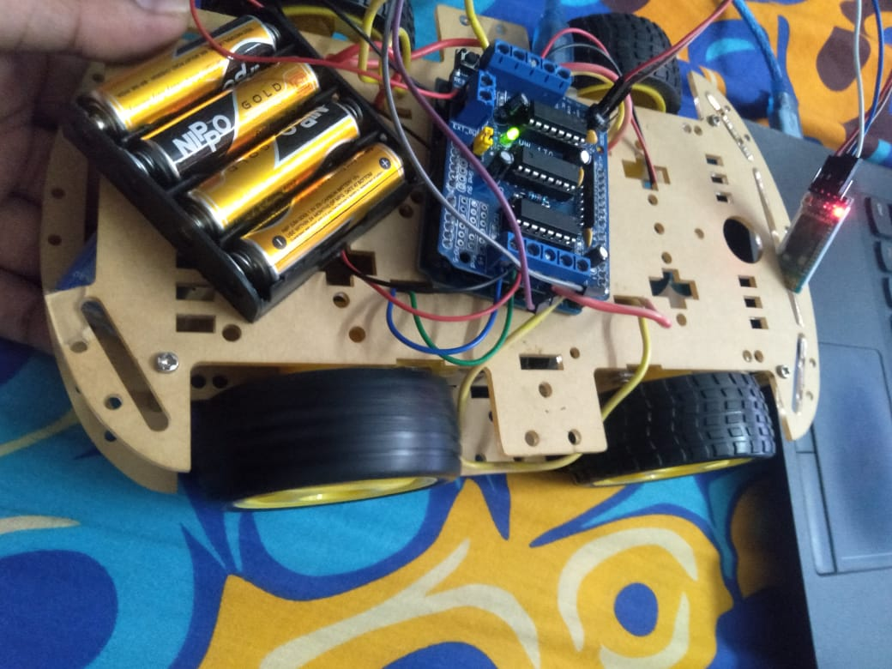

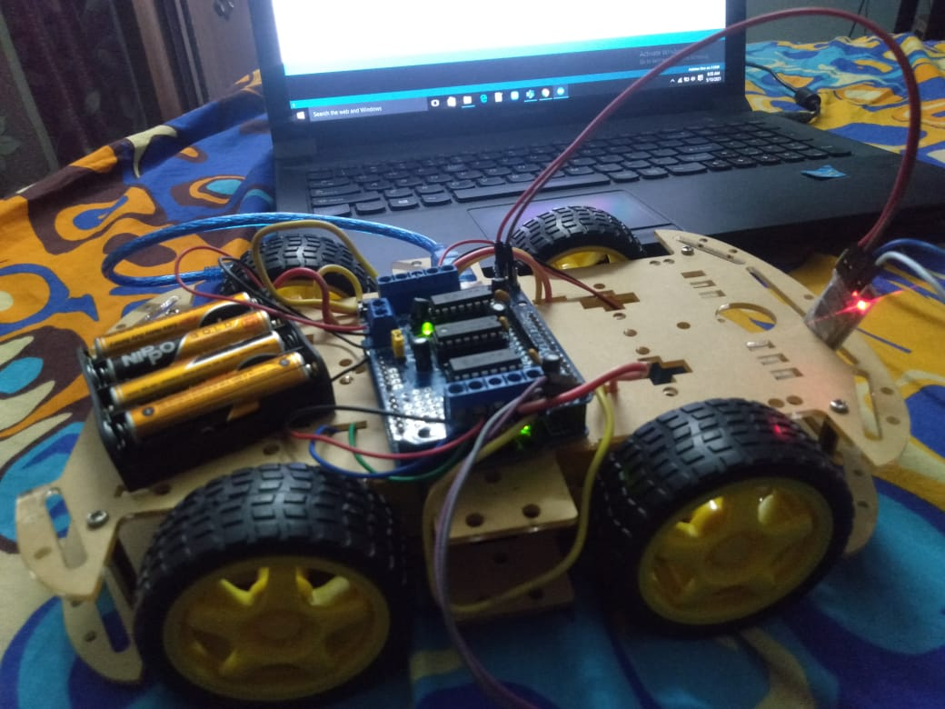

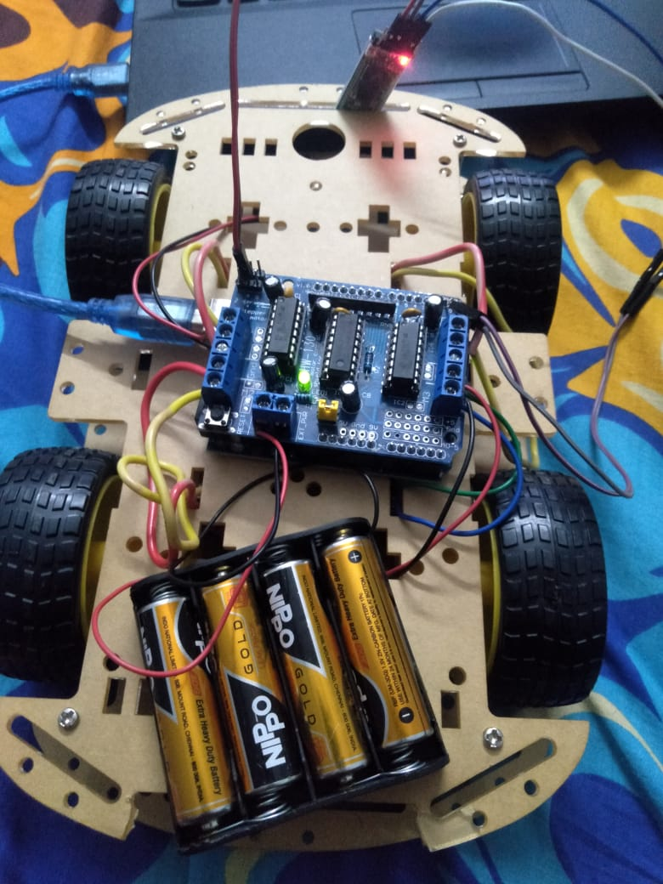

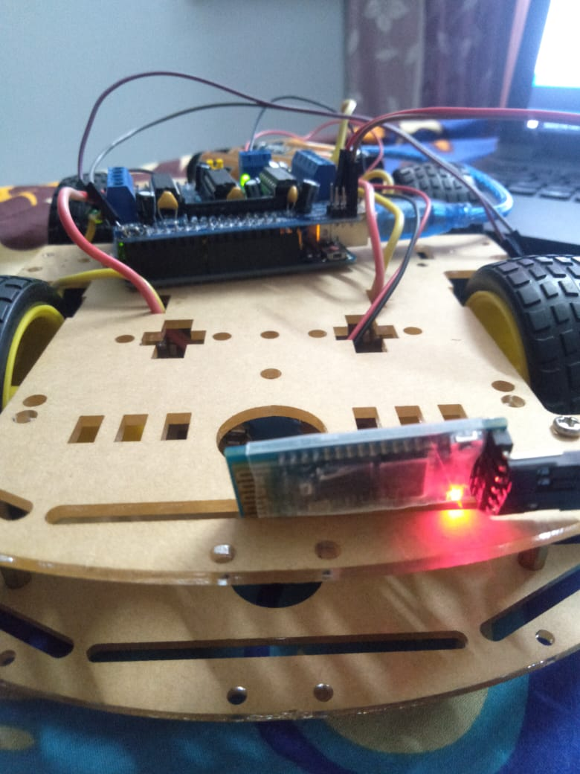

**CHAPTER-5**

**CONCLUSION& FUTURE WORK**

The Arduino is an open source device that has been the brain fornumerous projects. The Arduino has everything that is required by the user which includes its inbuilt converter, i/o pins etc. With the combination of Arduino, and the Bluetooth Shield we can control over many other things, like home Lightings, air conditioner and many more through our cell phones. The Arduino can also contribute at large for the SmartHome system. By doing this Project we found out a lot about the Arduino, and how it has made us easier to convert digital signals into physical movements. One more advantage of Arduino is that once a program is burned we don‘t need to worry about the program getting erased as long as it is not RESET. Arduino has also over all other microcontroller because of its efficiency and user friendly property.

**REFERENCE**

Reference paper—1:

* This paper deliberate how to control robot controlled car using Wi-Fi module through android application of an android mobile phone. It is also show that the appliances can be controlled even in the absence of an android phone by sending a normal SMS. This project can be modified quite easily to include a spy camera as well that can stream the videos to the user over Wi-Fi.
* AUTHORS--: **S R Madkar, Vipul Mehta, Nitin Bhuwania, Maitri Parida**
* YEAR OF PUBLISH-**2017**
* **CHANGES—lithium ion battery is used instead of solar cells**

Reference paper—2:

* A robot is usually an electro-mechanical machine that is guided by computer and electronic programming. Many robots have been built for manufacturing purpose and can be found in factories around the world. This paper develop the remote buttons in the android app which control the robot motion with them. And in which Bluetooth communication is use to interface controller and android. Controller is interfaced
* Authors : **Ritika Pahuja, Narender Kumar**
* **Year OF publishing—2017**
* **CHANGES—we used arduino instead of 8051 microcontroller**
* **https://www.google.com/url?sa=t&source=web&rct=j&url=https://www.researchgate.net/publication/313574397_Design_and_Implementation_of_a_Voice_Controlled_Robot_with_Human_Interaction_Ability&ved=2ahUKEwjSx8rA2u3uAhU8xDgGHfsdBwkQFjABegQIBBAC&usg=AOvVaw1nhkQYJqF2VZ4cOYDkRQTL**
* **https://www.google.com/url?sa=t&source=web&rct=j&url=https://www.researchgate.net/publication/329919803_Implementation_of_Voice-Controlled_Robotic_Vehicle_withAutomatic_Braking_and_Obstacle_Avoidance&ved=2ahUKEwjSx8rA2u3uAhU8xDgGHfsdBwkQFjACegQIBBAJ&usg=AOvVaw0h4QMuqgd1s8Khe4okZa0d**
* **https://www.google.com/url?sa=t&source=web&rct=j&url=http://ijirt.org/master/publishedpaper/IJIRT101709_PAPER.pdf&ved=2ahUKEwjSx8rA2u3uAhU8xDgGHfsdBwkQFjAEegQIBRAB&usg=AOvVaw0PiwPCsLMpGzT4DlHvLAdX**

## 